**Experimental procedure for the 500 foot moored balloon test**

Formulated August 6, 2019 for use by the Engineering Mechanics and Space Systems Laboratory

North Carolina State University

Engineering Building III, Room 3406

The following procedure as described is to be followed while performing 500 foot moored balloon test. The steps are grouped in sections with each section having a stage number.

**Prep and travel procedure (all)**

1. The team is to arrive at the lab on the morning of the test one hour prior to launch. All items for the test, equipment to be used, and other items needed should be packed and labeled clearly before the team leaves the lab. The packing checklist of all items required must be completely filled out before the team may leave the lab.
2. All test items are to be transported from the lab to the launch site. All parties driving should be made aware of the launch site and route.
3. Once at the launch site, the team is to unpack all items and distribute them in such a manner which the entire team is aware of the location of each item. Tarps are suggested in order to space everything out on the ground for ease of visibility. A pop-up tent is suggested to provide shade to all parties.

**Balloon inflation procedure (3 people)**

1. Begin the balloon inflation process. To do so, allow one team member to hold the balloon and restrain the balloon from touching the ground and lifting off prematurely (this person needs to have latex gloves on to handle the balloon). A second team member is responsible for clamping the neck of the balloon to the nozzle of the inflating assembly and is also responsible for preventing a premature ascent (also with latex gloves). A third team member should be regulating the amount of helium flowing into the balloon (no gloves needed).
2. Place the neck of the balloon on the inflation tube.
3. Place the aluminum balloon restraints on either side of the balloon neck. Place two hose clamps around the balloon restraint pieces.
4. Place the handles around the base of the balloon inflation tube. Place the third hose clamp around the handle pieces.
5. Tie two tethers from the inflation handles to a carabiner (or clip) that are both a double length. One should be 1 foot long and clip to the fish scale. The second is a safety line, be two feet long, and clip to a stake in the ground (safety line). The other end of the fish scale should attach to a tether also anchored to a stake in the ground.
6. Inflate the balloon until the balloon contains enough helium to generate **X.XX kg** of lift (based on the weight of the system known beforehand). To measure the lift, gently let go of the handles and let the fish scale take the load. Once at the desired inflation volume, attach the tie down tether to the balloon stem (this tether is to tie the balloon to a car for ease of working with the balloon after inflation and before launch).

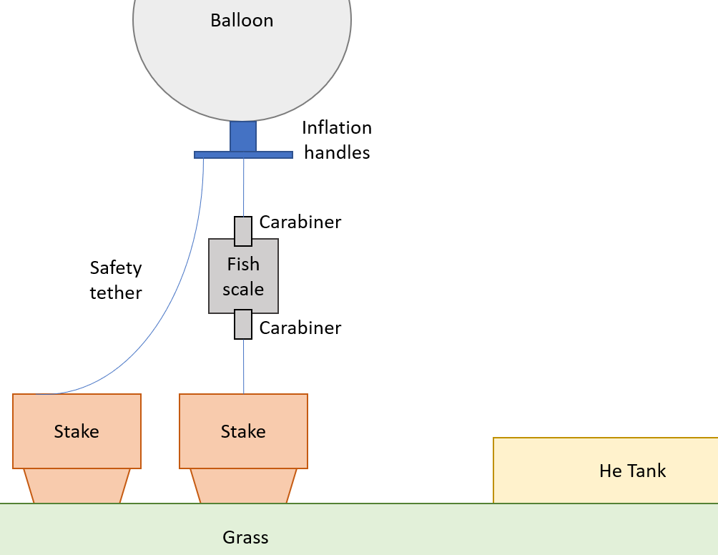

1. Attach the connecting tether to the balloon stem. Fold the balloon stem so that the open end of the stem is pointed upwards. Tie off the stem to prevent helium from leaking out of the balloon. Secure the tie off using electrical tape. Tie the other end of the connecting tether to an anchor to prevent it from flying away.

**Tether preparation procedure (1 person)**

1. Layout and fix enough stakes in the ground as needed (should be 20 stakes for 500 ft). The 1st stake will also act as the anchor point for the main tether.
2. Both groups will be driven into the ground to form 2 straight parallel lines. The two lines will be 25 feet apart from each other. The arrangement of the stakes is a sketched below.
3. Tie one end of the main tether to the 1st stake tether. Then layout the tether such that it zig-zags between the two parallel lines of the stakes.

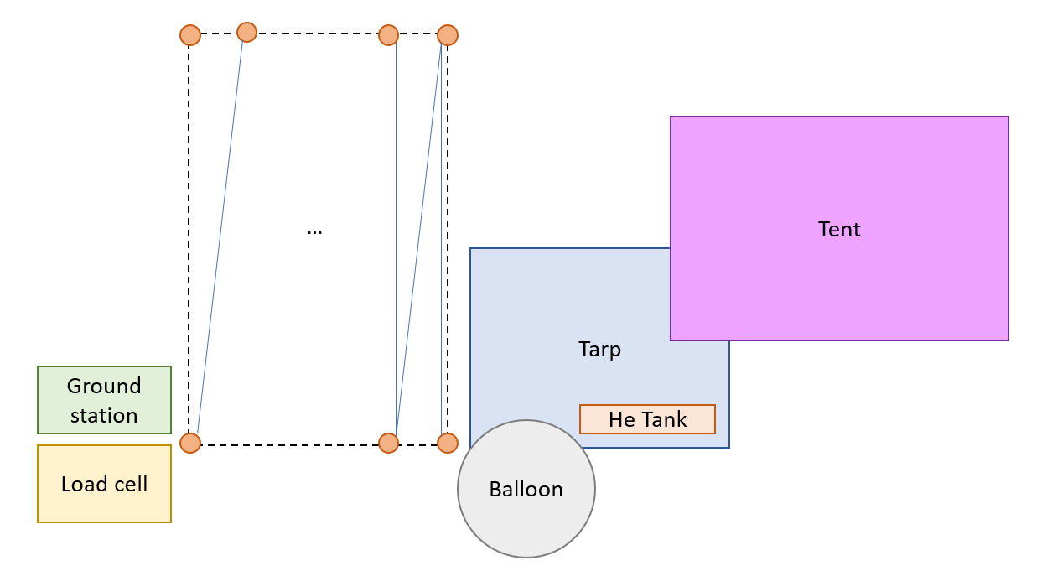

**NOTE: After the tether has been placed along the stakes, the tether is hard to see against the green grass. No team member should walk in between the two parallel lines of stakes as this presents a tripping hazard. If it is imperative that a team member pass between the two lines of stakes, that team member should only walk in a perpendicular line from one side of the stakes to the other as to prevent tripping as much as possible.**

1. At each streamer location (every 50 feet), cut a streamer to length. Attach the streamer to the tether (at one streamer end) using duct tape.
2. The opposite end of the mooring line should be connected to the load cell. To do so, attach the carabiner of the mooring line to the ring above the load cell. If two mooring lines are used, then both need to be attached via carabiner to the load cell ring.

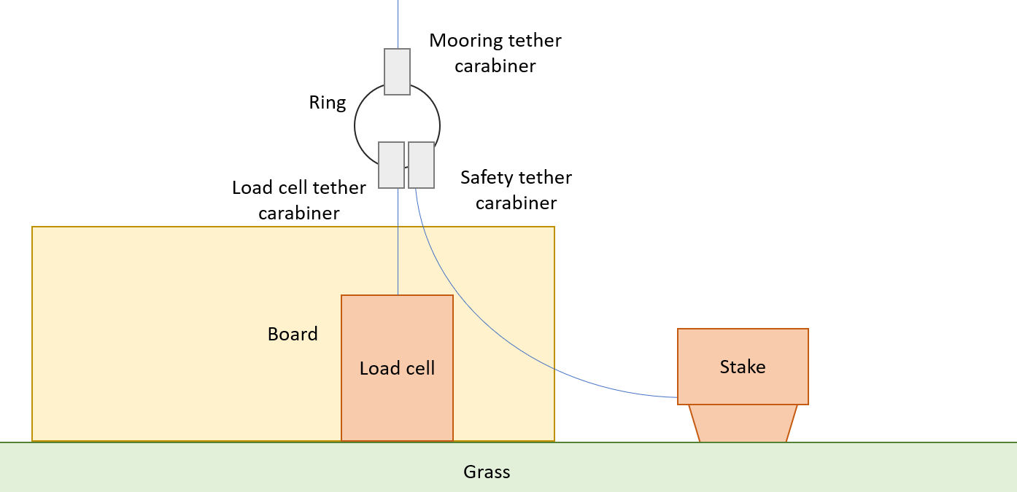

1. Connect the ring above the load cell to the load cell using the load cell tether.
2. Attach the safety tether from the load cell ring to the safety stake.
3. Connect the load cell to the board mechanically using a bolt in the base of the cell.
4. Attach the load cell amplifier via the two cables. One should go to the load cell and the other to the protoboard header blocks.
5. To power the load cell, add the power cable from the brick battery to the soldered wire. Attach an alligator clip from the red power wire to the red wire in the terminal block soldered to the red wire. Connect a second alligator clip from the barrel connector on the power cable to the terminal block soldered to the black wire on the protoboard.
6. Plug the power cable into the 12 VDC slot on the brick battery. Turn the switch next to the 12 VDC source on the battery to “on.”
7. Power on Saurabh’s laptop. Open the LabView VI to read load cell values.
8. Change the m and b values to those specified in the descriptions on the VI.
9. Run the VI. Confirm that data is being collected by pulling on the load cell tether and observing an increase in tension. Confirm data is being saved by stopping the VI, opening the text file, and confirming that data is collected. Run the file again to resume data collection.

**NOTE: The data file must be a new file each time. LabView cannot save over an existing file using this VI.**

1. At unique milestones in the test (deployment complete, every third test, etc), manually save the data and re-launch the VI. Save the filename with a unique identifier to identify the period when the file was launched (suggested to name the file by the date and time of launch, e.x. 2019-08-10-14-30-file.txt)

**Ground station (1 person)**

1. Unpack the ground station.
2. Drive the rod into the ground. Place the ground station on top of the rod.
3. Orient the ground station such that the sled points towards magnetic north.
4. Hold the wind vane such that the nose (lobed end) points towards the north.
5. Power on the gondola while holding onto the weather vane. Hold the vane for ~30 seconds while the ground station powers on and the GPS gets a fix. Let go of the vane and let the ground station run throughout the test.

**Gondola preparation procedure (1 person)**

1. Unpack the gondola and circuits. Move to a working station under the tent (to keep the electronics cool).
2. Attach the cutdown circuit to the gondola tether between the balloon and gondola. Make sure the gondola tether is attached to the gondola hook
3. Confirm that the gondola switch is in the off position (red marker).
4. Connect all wires needed to the gondola circuit.
5. Confirm that the cutdown is switched off. Power on the gondola circuit. Confirm a successful power on by rotating the gondola and observing the LED color changes. Slide the circuit into the gondola housing.
6. Add the GoPro and other items to the gondola as needed.
7. Attach the parachute to the gondola using a carabiner. Place the carabineer through all of the parachute cords and through the gondola eye bolt loop. Place a SMALL piece of tape around the top of the parachute and gondola tether in order to keep the parachute taught and un-deployed.
8. Attach the gondola to the mooring tether carabineer. Attach the sail tether using a second carabineer.

**Sail preparations (1 person)**

1. Unpack the wing, boom, sail electronics, and rudder from the car.
2. Attach the wing to the boom using the aluminum couplers. Attach the wing tip ballast box using a similar method.
3. Attach the two eye bolts to the boom. Attach the sail bridle tethers to the boom. Attach the other ends to the sail ring.
4. Attach the rudder spar using the rudder angle position system. Confirm that the rudder is aligned roughly with the zero setting on the positioner relative to the wing.
5. Attach the sail electronics to the boom:
   1. For the classic sail, the electronics go onto the end of the boom ahead of the wing.
   2. For the canard configuration, the electrics need to go ahead of the wing but behind the rudder for balance. This may require removing the eyebolts to position the electronics appropriately.
   3. For the upside down sail, the electronics should be placed at a similar location to the classic sail.
6. Once attached, power on the sail electronics. Confirm that the electronics are working using the LED color scheme with attitude change.

1. Attach the sail tether to the sail using a carabiner on the sail ring.

**Launch and test**

1. Double check that all pieces are tethered together and that the system is operational.
2. Confirm that data is flowing through the telemetry system.
3. One person needs to hold onto the balloon and stand above the gondola. One person needs to hold the sail downwind of the balloon (the sail tether should be completely spooled out). A third person needs to hold the main mooring tether (using gardening gloves) below the gondola. A fourth person needs to be documenting the launch in pictures or videos. A fifth person should be commanding the operation.
4. Gently release the balloon. Allow the balloon to stand up fully supporting the gondola but restrained by the person holding the mooring tether. Confirm there are no issues.
5. Deploy the system. The person holding the mooring line should walk back and forth letting the tether deploy. When a streamer is encountered, the person should transfer one hand from behind the streamer to ahead of the streamer, then the second hand. One hand should remain on the tether at all times.
6. When a stake is encountered, a second person should free the mooring tether from the stake and allow the deployment person keep walking. Repeat for all stakes.
7. When arriving at the ground station, make sure that the tether is still attached to the load cell. Gently transfer load from the person to the load cell.
8. To retrieve the test, follow the above steps in reverse. Repeat for as many tests as needed.

**Pack up procedure (Stage 5)**

1. Remove the circuit from the gondola and retrieve the SD card. Tie the balloon to the connecting tether again so that it does not fly away.
2. Disconnect the connecting tether from the balloon. Remove the tape from the balloon stem and remove the rubber bands. Slowly let the helium out of the balloon.
3. Wind up the tether and pack the balloon away. Collect all washers and sensor packets and load the cars.
4. Upon returning to the lab, store all balloon containers in the appropriate locations within the lab. Upload the data to a secure place (Google Drive) for post processing purposes later. Document all issues and notes from the test.

# Appendix A: Packing checklist

This checklist is meant to be used before leaving the lab on the morning of the flight and before leaving the launch site to return to the lab. The purpose is to make sure all items borrowed from the lab and items associated with the experiment are taken for use and returned to the lab.

|  |  |  |
| --- | --- | --- |
| **To** | **From** | **Item** |
| [ ] | [ ] | Balloon; one for launch and at least one backup |
|  |  |  |
| [ ] | [ ] | Helium |
|  |  |  |
| [ ] | [ ] | Tethers; main tether, connecting tether, tie down tether, flight spool tether, plus extra for emergency repair |
|  |  |  |
| [ ] | [ ] | Sail (wing, rudder, boom, sensors, couplers, carabineers, etc) |
|  |  |  |
| [ ] | [ ] | Gondola and extra cardboard for emergency repairs |
|  |  |  |
| [ ] | [ ] | Washers |
|  |  |  |
| [ ] | [ ] | Gondola sensors (batteries, electronics package, magnetometer) |
|  |  |  |
| [ ] | [ ] | Gondola emergency cut down system (analog electronics, parachute, nichrome wire, batteries); extra nichrome wire and batteries |
|  |  |  |
| [ ] | [ ] | Scientific notebooks for documentation |
|  |  |  |
| [ ] | [ ] | Pens/Pencils for writing |
|  |  |  |
| [ ] | [ ] | Blanket and tarps (workstations) |
|  |  |  |
| [ ] | [ ] | Ground station electronics (batteries, sensors) |
|  |  |  |
| [ ] | [ ] | Duct tape, electrical tape, masking tape |
|  |  |  |
| [ ] | [ ] | Canopy (or tent) for shade |
|  |  |  |
| [ ] | [ ] | Tools (wrenches, screwdrivers, utility knife, superglue) |
|  |  |  |
| [ ] | [ ] | Computer (laptop) for post processing on site to verify data collection |
|  |  |  |
| [ ] | [ ] | Gloves for tether manipulation |
|  |  |  |
| [ ] | [ ] | Latex gloves |
|  |  |  |
| [ ] | [ ] | Rubber bands for tying off balloons |
|  |  |  |
| [ ] | [ ] | Copy of all experimental procedures, goals, etc. for reference |
|  |  |  |
| [ ] | [ ] | Pressure regulator assembly |
|  |  |  |
| [ ] | [ ] | Fish scale and associated batteries (digital) |
|  |  |  |
| [ ] | [ ] | Anchor and hammer |
|  |  |  |
| [ ] | [ ] | Balloon inflation handles, hose clamps, wrench, etc. |
|  |  |  |
| [ ] | [ ] | Stakes, mallet, string for no-go zone |
|  |  |  |

# Appendix B: Pre-flight checklist

Below is a checklist which must be completed before flight may occur. It is up to one team member who is independent of the preparation for the test to make sure that each item on the checklist is accounted for before flight begins.

|  |  |
| --- | --- |
| **Check** | **Task** |
| [ ] | Verify that all items on the packing checklist have been unpacked and placed on the ground in easy-to-identify locations. |
|  |  |
| [ ] | Confirm the stakes are placed in the ground and properly hammered in. |
|  |  |
| [ ] | Verify the main tether is intact and staked down. |
|  |  |
| [ ] | Verify the tie down tether, the connecting tether, and the flight spool tether are intact. |
|  |  |
| [ ] | Assess the status of the gondola and make sure that the gondola is structurally intact and ready for flight. |
|  |  |
| [ ] | Make sure that the weather for the next three to four hours is clear and there is little chance of bad weather for the test. |
|  |  |
| [ ] | Erect the canopy for use in the test. |
|  |  |
| [ ] | Verify the ground station is deployed and anchored to the ground |
|  |  |
| [ ] | Distribute responsibility to team members for the test. |
|  |  |
| [ ] | Ensure that one team member is holding onto the balloon while the other is inflating the balloon. Make sure the inflation occurs under the canopy. |
|  |  |
| [ ] | Ensure that all team members involved in balloon inflation are wearing latex gloves. |
|  |  |
| [ ] | Ensure the balloon is secured with rubber bands prior to the connecting tether and the tie down tether to the stem. Make sure one person is holding the balloon stem closed while another prevents the balloon from ascending freely. |
|  |  |
| [ ] | Ensure the tethers get tied to the balloon and the connection is secure. |
|  |  |
| [ ] | Ensure rubber bands are placed on the stem after the balloon is connected to the tethers. |
|  |  |
| [ ] | Ensure the tie down tether is attached to a vehicle and that the balloon is still within the canopy. |
|  |  |
| [ ] | Verify the balloon stem is folded upwards and rubber bands secure it in place. Make sure duct tape is then attached around the stem. |
|  |  |
| [ ] | Verify the gondola is attached to the main tether. |
|  |  |
| [ ] | Verify the nichrome is attached to the cutdown system. |
|  |  |
| [ ] | Verify that the parachute is packaged properly and attached loosely to the connecting tether. In the event of cut down, this parachute should deploy. |
|  |  |
| [ ] | Ensure the gondola electronics are powered on are working properly. Make sure that the sensor package is secure within the gondola and the gondola is sealed for flight. |
|  |  |
| [ ] | Verify that team members have gloves on. |
|  |  |
| [ ] | Make sure that the main tether is connected to the gondola. Make sure that the flight spool is connected to the flight spool tether and the flight spool tether is fixed to a vehicle. |
|  |  |
| [ ] | Verify that the gondola circuit is powered on prior to the cutdown system being powered on and both are working properly. |
|  |  |
| [ ] | Verify telemetry is operational prior to launch. |
|  |  |
| [ ] | Make sure all team members are being safe during the ascent phase of the experiment. |
|  |  |